1. In the below elements which of them are values or an expression? eg:- values can be integer or string and expressions will be mathematical operators.

\*

Ans: This is expression

'hello'

Ans: This is Values

-87.8

Ans: This is values

-

Ans: This is expression

/

Ans: This is Expression

+

Ans: This is Expression

6

Ans: This is values

2. What is the difference between string and variable?

Ans: A variable can be defined as a symbol where data can be stored.It can vary.For understanding we can consider it as a empty space where a data can be stored.

String can be defind as the information or data to be stored in place of variable to give it a value.The strings can be of any type for example integer,floating point or words.  
usually strings are in form of words with single or double quote.

Eg: “shweta”, ‘data science’

3. Describe three different data types.

Ans: Three different data types are:

Integer: it can be defined as data types which represent any whole number eg 100,99 54 etc.

Floating point: These are data types having number with decimal values eg: 100.65 ,21.42

Boolean Expression: This are data types which represent values only in logical expression eg “TRUE” or “FALSE”

for eg:

a= 17 ,b= 19

a<b

“TRUE”

Here value of a is less then b so in Boolean expression it is TRUE

4. What is an expression made up of? What do all expressions do?

Ans: An Expressions is made up of operands and operators.

For eg a+b+c-d>>e

In this example ‘a’, ’b’, ’c’, ’d’ ,’e’ are operands and mathematical symbols such as ‘+’ , ’-’ ,

‘>’ are operators.

An expression works as instructions for operators and operands to give a single value

Eg: 4+5+6+7-4= 18

5. This assignment statements, like spam = 10. What is the difference between an expression and a statement?

Ans: Every line while coding in python is a statement.

Eg: Print(“This is my laptop”)

a=10

In this assignment statement value of ‘a’ is assigned as 10.

Expression is different from statement because it evaluates and give result or values for ex :

X+10 =45

In this example different value of x gives different values.

6. After running the following code, what does the variable bacon contain?

bacon = 22

bacon + 1

Ans:

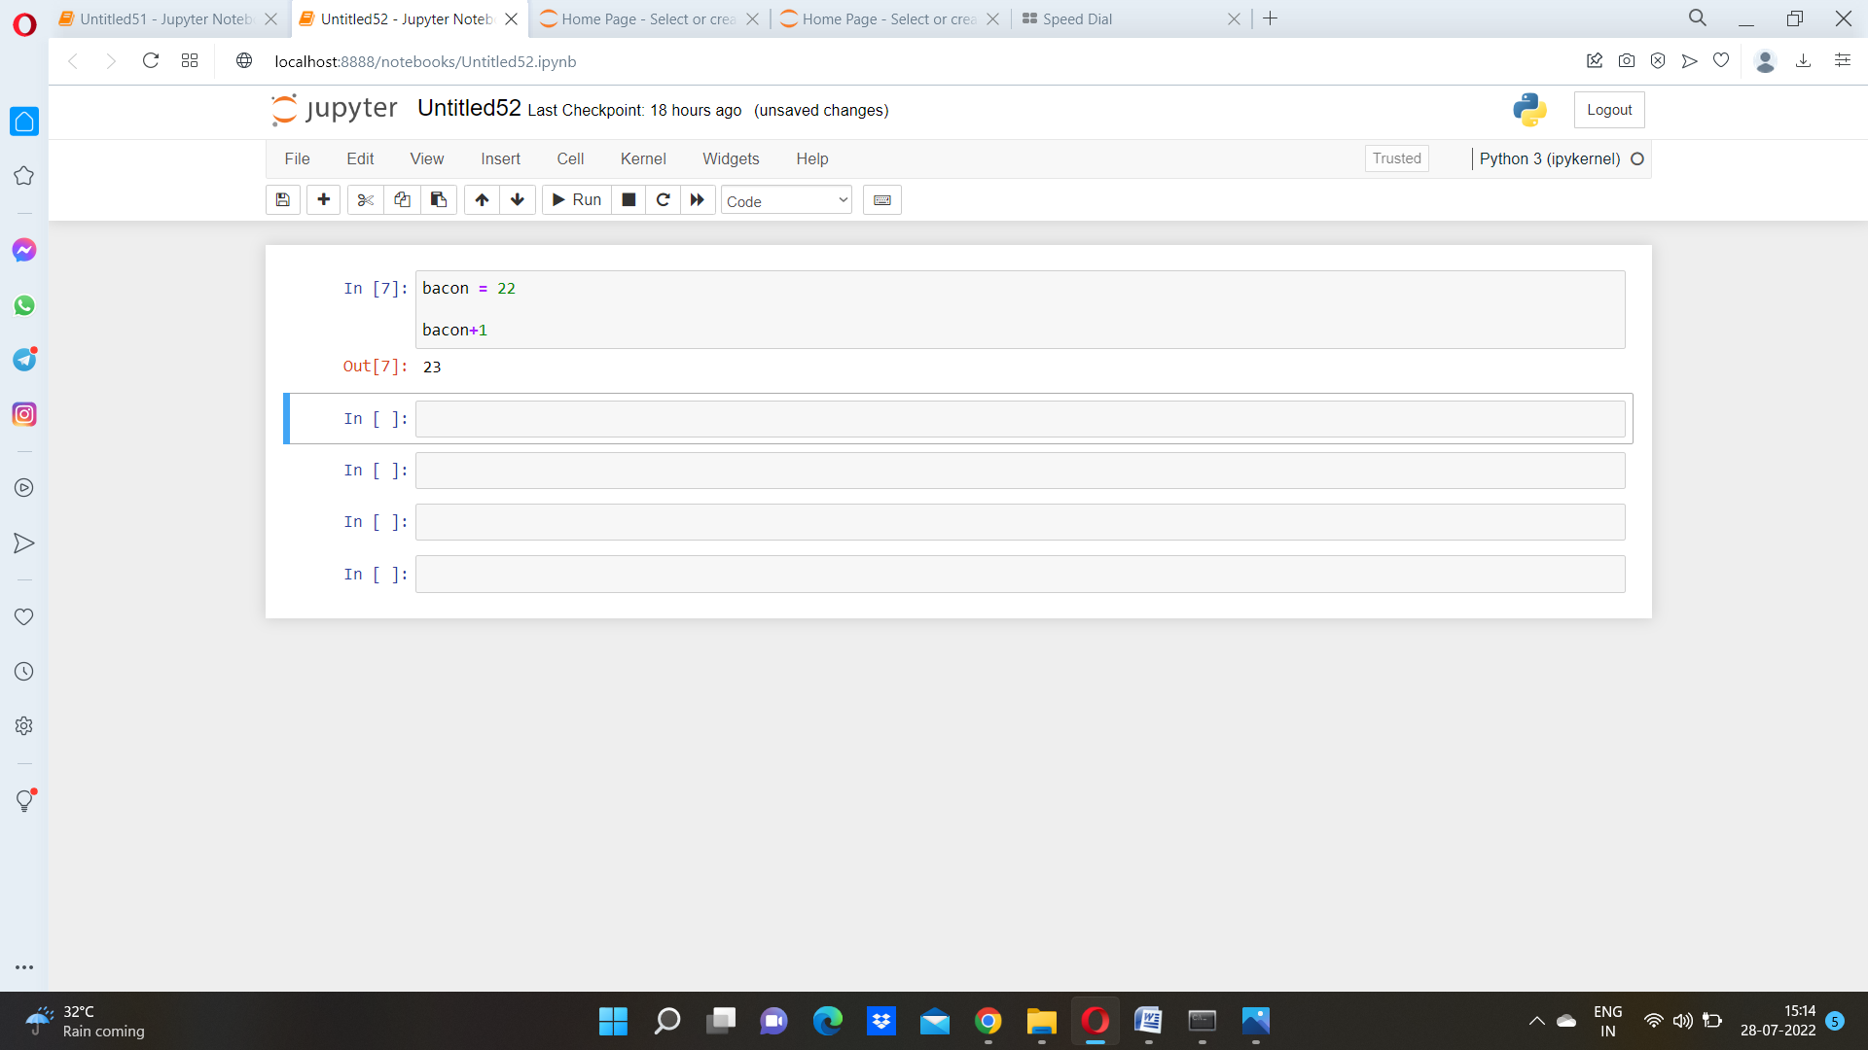

7. What should the values of the following two terms be?

'spam' + 'spamspam'

'spam' \* 3

Ans:

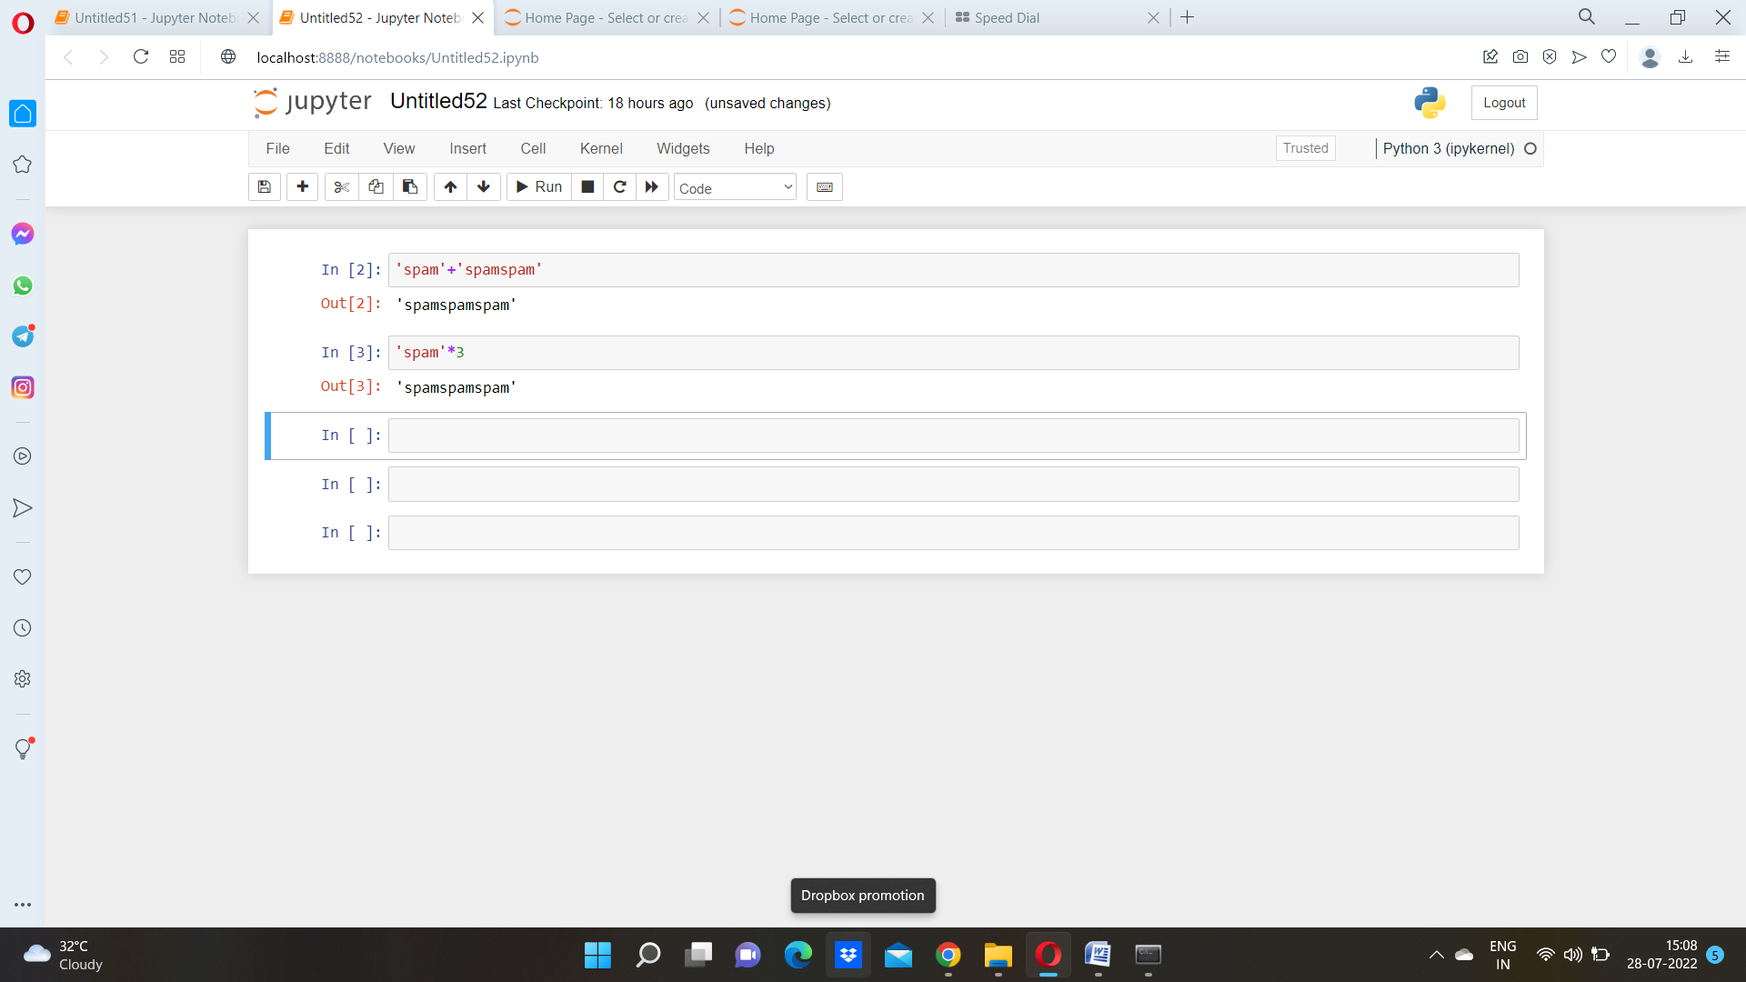

8. Why is eggs a valid variable name while 100 is invalid?

Ans: “eggs” is valid variable because variable can be initiated with numbers so “eggs ” is valid variable but 100 is invalid

9. What three functions can be used to get the integer, floating-point number, or string version of a value?

Ans: Integer= int()

Floating point= float()

String= str()

10. Why does this expression cause an error? How can you fix it?

'I have eaten ' + 99 + ' burritos.'

Ans: in the execution of this code it gives error as ‘can only concatenate string (“”not int) to str ’

Screenshot for same attached herewith

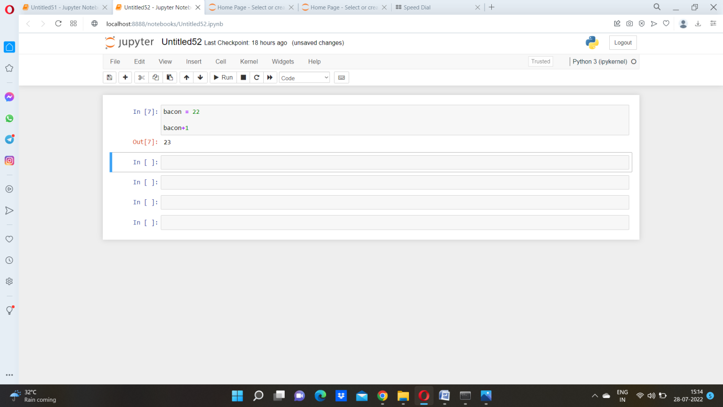

This can be concatenated while typecasting the integer 99

Again screenshot shows the correct coding:

